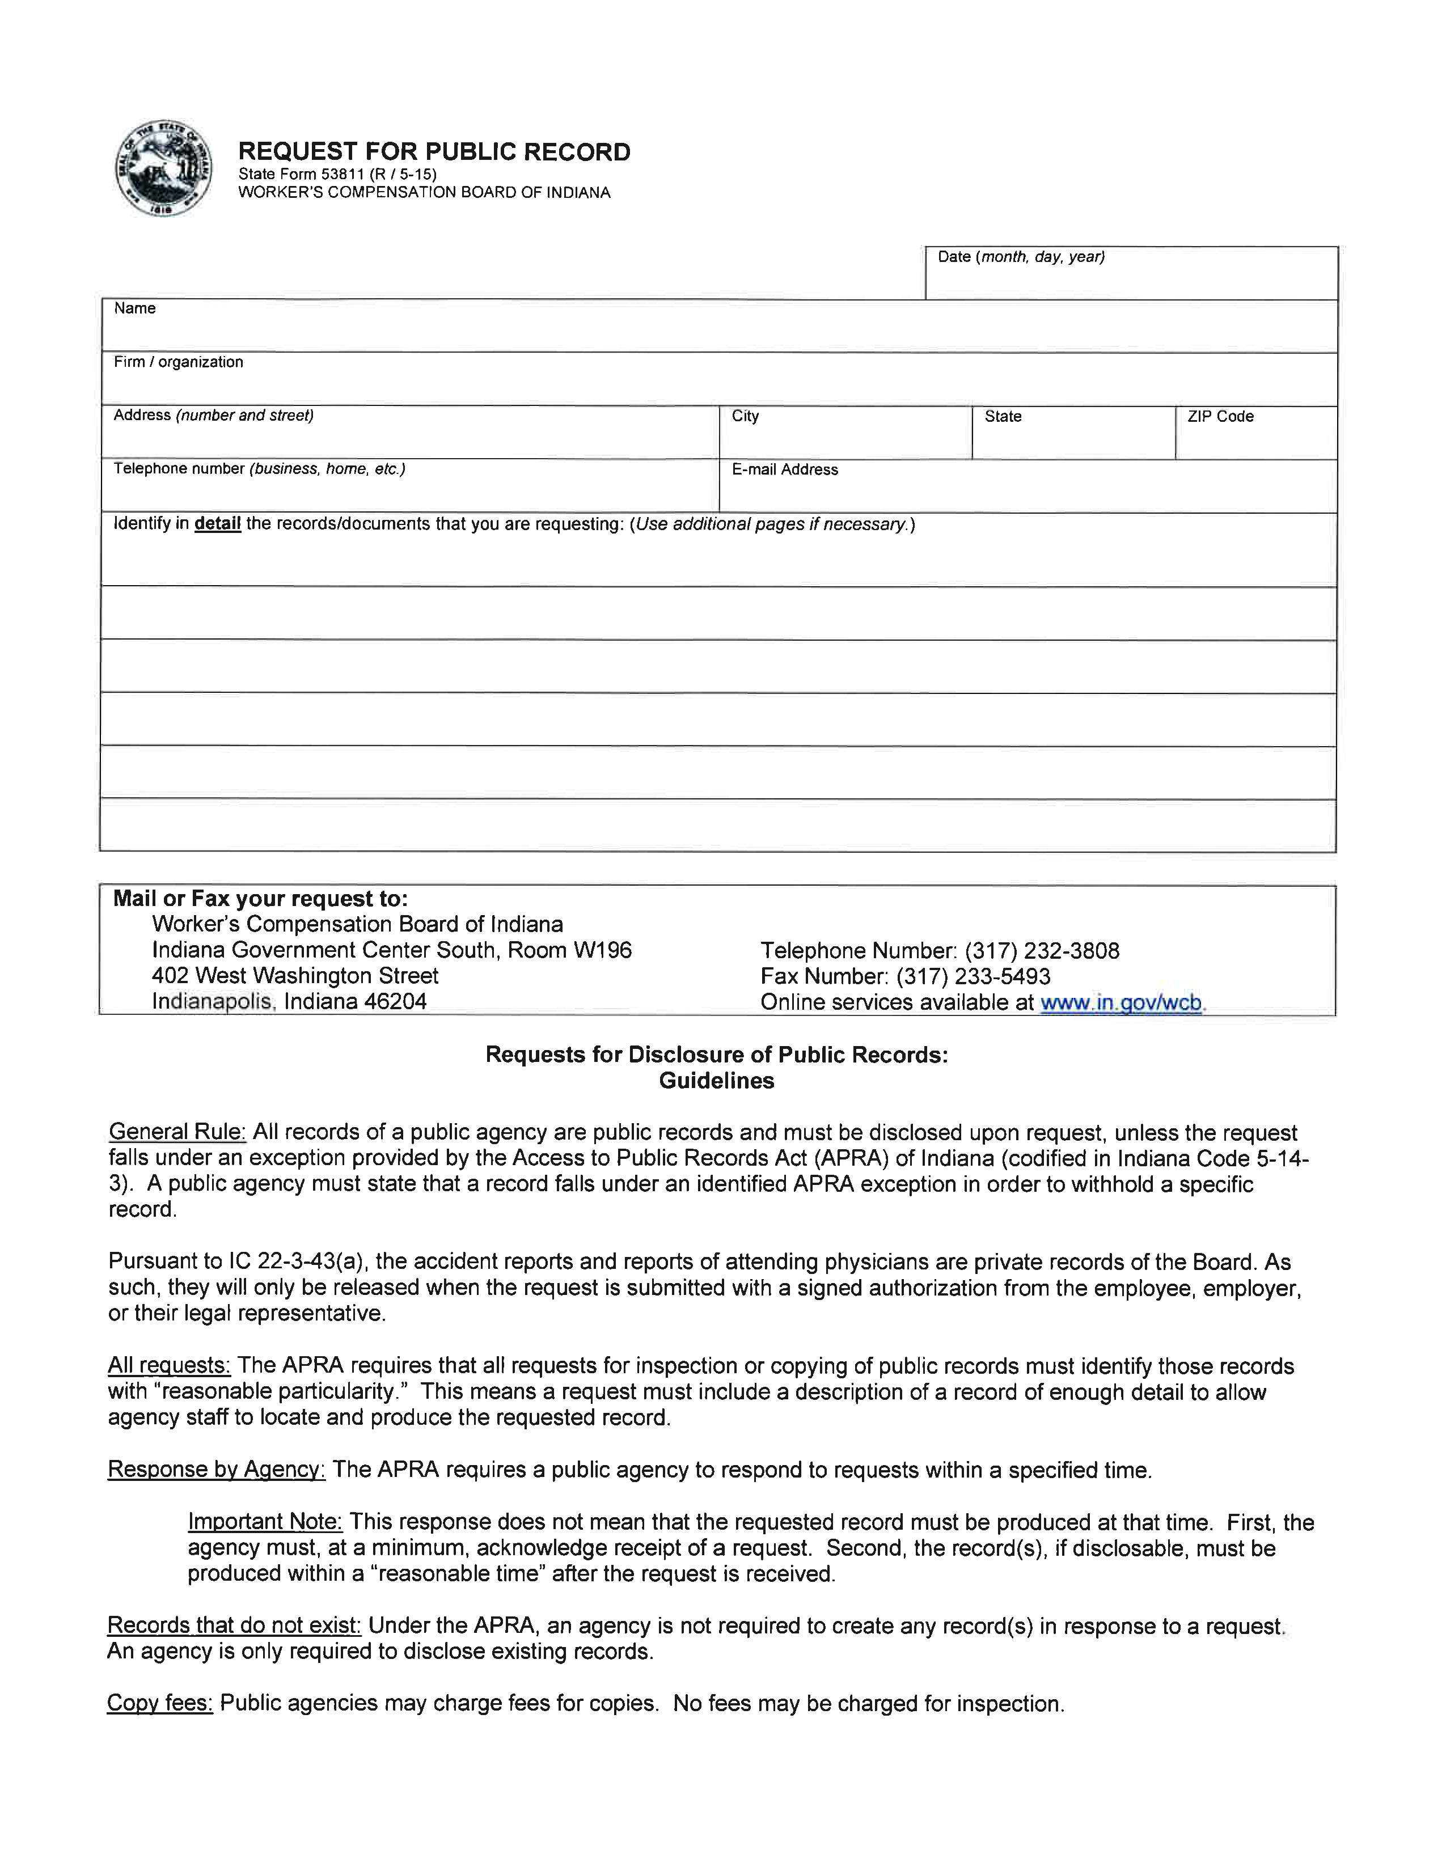

Axiom Requisition Copy Service
2869 Jolly Road
(877) 886-5090
Okemos
MI
48864
Records@axiomcopy.com
FROM 01/01/1979 TO PRESENT: Any and all MEDICAL RECORDS, including but not limited to patient history form(s), reports, etc. pertaining to Batman SSN: xxx-xx-5555, DOB: 01/01/1979.
Order No. 01-29018-002

